

California State University of San Marcos

Jordan Fisher, Juan Gonzalez, Keith Gross, Miguel Morales , Noah Miera

CIS490 : Dr. Shaun-inn Wu

### Table of Contents

1. **Application development**

1.1 Statement of Business Context 4

1.2 Statement of Customer’s Business Problem 4

1.3 Statement of Project Proposal 4

1.4 Statement of Deliverables 4-5

1.5 Measures of Success 5-6

1.6 System Overview 7-8

1. **Requirements Matrix** 9
2. **Project Management**

3.1 Product Breakdown Structure 10

3.2 Work Breakdown Structure 11

3.3 Initial Schedule for Tasks and Deliverables 11-14

3.4 Statement of Total Cost 14-15

3.5 Gantt Chart 15-19

3.6 Initial Project Cost Tracking Chart 20

3.7 Statement of Deliverables 21

3.8 Outline of Resources Needed 21-22

1. **Team - Appendix**

4.1 Access to Project 22

4.2 Attendance Records 22

4.3 Timesheets 23-25

4.4 Sprint Meeting Minutes 26-28

To: Jared Macshane, Machine Learning Supervisor

CC: Dr. Shaun-inn Wu, Director of Projects

The Sushi Team is grateful to be able to be part of this for Keep America Beautiful. Thank you Jared, as well as Dr. Wesley Schultz, for not only this opportunity to work in the Machine Learning field for this project, but also to work on something that helps build and maintain clean, green, and beautiful spaces in America. We look forward to working and learning from you this Spring semester of 2022, in order to assist in the making of this project.

In this fourth phase, the team aimed towards the refinement of our system to process and detect litter in Google Street images from a user, for our Machine Learning project for Keep America Beautiful. Such progress so far has led us to the integration of the YOLOv5 object detection model in our Google Cloud server - with training and testing to detect litter in Google Street images, and the modifying of our Python script that formulates the process of our system - pertaining to outputs, and it’s compatibility to the YOLOv5 model now, versus the YOLOR model before. Additionally, we have synced up with the Web App team, going over our hook with them through a TCP connection, so that they can use the Machine Learning algorithm, as well as accessible litter metrics. In the coming phase, we will strive to delve deeper into the development of our Machine Learning algorithm’s results, refining its ability to detect litter in Google Street images, and possibly categorize litter as well.

Regarding the projected cost of this project, the Sushi Team has determined that we will “charge” a rate of $23 per hour, per member of our team. In this fourth phase, we have accumulated a cost of $4,278.46 through 179.35 labor hours, and an accrued cost of $153.41 from our Google Cloud server. In the next phase, we estimate a cost of $3,772.00, through 164 labor hours. With this rate and the currently accrued actual costs of Phases 1, 2, 3, & 4, we estimate the total cost of the project to come to a total of $17,337.17, through a total of 583.12 completed hours, an estimated 164 future hours, and an accrued cost of $153.41 from our Google Cloud server. Should alternative or additional costs be required, the costs will be updated accordingly.

By signing below, you hereby approve Sushi Team to continue working on the following project: Keeping America Beautiful: Litter Detective and agree to the aforementioned estimated costs.

From, Team/Scrum Leader: Noah Miera

_________________________________________

*Jared Macshane, Machine Learning Supervisor*

### 1. Application Development

**1.1 Statement of Business Context**

Keep America Beautiful is a leading national nonprofit organization that inspires and educates people to take action every day to improve and beautify their community environment. They envision a country in which every community is a clean, green, and beautiful place to live.

**1.2 Statement of Customer’s Business Problem**

* Need a new Machine Learning algorithm to produce data on Google Street images containing litter.
* Needs the data to not only detect if there is litter, but also categorize them.
* Make the results available and usable for the Web App team.

**1.3 Statement of Project Proposal**

* 1. Process Google Street images through a pre-trained model.
* 2. Adapt model to our specific needs of litter detection.
* 3. Collect output data/results.
* 4. Sync up input/output format with the Web App team.
* 5. Make results accessible to the Web App team.

**1.4 Statement of Deliverables**

* Machine Learning code/algorithm that will be compatible and usable with the Web App team.
* Algorithm will produce data that will include:
  + Identification of litter in an image.
  + The total amount of litter.
  + Show the detection accuracy in testing (e.g. 90% sure this is a Plastic bottle-Litter).
  + *Striving for/Conditional features*:
    - Categorize the litter (e.g. Plastic bottle, Paper bag).

We will strive to deliver a new Machine Learning algorithm for Keep America Beautiful, developed through Python in a Anaconda/Miniconda environment, that will output usable and available results for the Web App team.

**1.5 Measures of Success**

The Sushi Team will perform the following tasks in order to accomplish the requirements listed in the proposal.

* JAD #1 - Identify initial requirements and technical specifications for the project.
  + Connect to a Google Cloud Server.
  + Establish Anaconda/Miniconda environment.
  + Read documentation/code of TACO’s pre-trained model.
  + Collect/Annotate Google Street images for future initial testing.
* JAD #2 - Identify the final requirements and technical specifications for the project.
  + Further collect Google Street images for future initial testing.
  + Establish extra student labor to assist in Google Street image annotations, and the access to software and Google Street images they will need.
  + Research object-detecting pre-trained model options for our detecting litter process.
* Prototype #1 - Process images through the Machine Learning algorithm to produce litter metrics.
  + Fully utilized and integrated the YOLOR object detection model into a Google Cloud server.
  + Trained the YOLOR model with a previous group's Google Street image dataset for litter detection (converted through Roboflow).
  + Wrote a Python script to establish an input/output format, with a TCP connection, for the utilization of the Machine Learning algorithm.
  + Began to look into possible different sources of litter related datasets to better the results of our Machine Learning algorithm for Google Street images.
  + Modified previous group's Google Street image dataset annotations to try to get better results for the algorithms litter detection.
* Prototype #2 - Able to sync up the input/output format of the Machine Learning algorithm with the Web App team, as well as refine the algorithm's litter detection.
  + Fully utilized and integrated the YOLOv5 object detection model into our Google Cloud server. Transitioning from the YOLOR model.
  + Trained the YOLOv5 model with a previous group's Google Street image dataset, re-annotated by us, for refined litter detection. Involved:
    - Tiling Augmentation
    - Hyperparameter Evolution Training
    - Tiny Bounding Box Rejection
    - Test Time Augmentations
  + Modified our Python script to work with our new results, as well as become compatible with the YOLOv5 model, and its latest version.
  + Synced up with the Web App team, establishing a hook with them so that they can use our Machine Learning algorithm, as well as accessible litter metrics.
  + Began working with provided students from Dr. Schultz on a new Google Street image dataset, in order to aim towards the categorization of litter for our Machine Learning algorithm. (Still a work in progress.)
* Final Product - Collation and transfer of litter metrics from images, received by the Web App team, that have been processed through a Machine Learning algorithm, for use by the Web App team.

**1.6 System Overview**

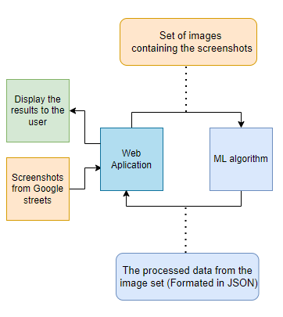

* Closer View of the System - Prototype #2

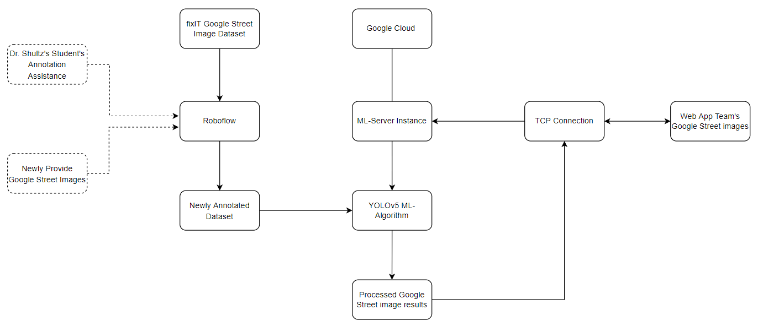

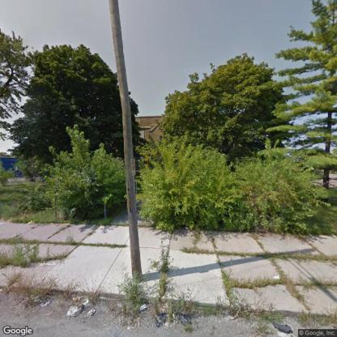







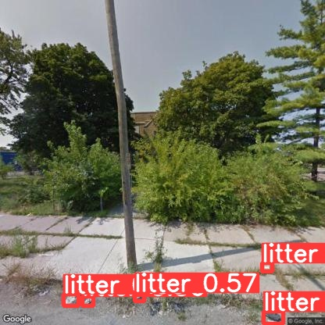 

*(Disclaimer: Cropped images to fit in document.)*

* Currently, we have created a system that can receive and process Google Street images from a user, in which a Machine Learning algorithm will be able to detect instances of litter in the received Google Street images. Once the litter instances have been identified, the system will then output the results into an image with bounding-boxes, identifying the litter, and a JSON file, textualizing the results, for the user.

### 2. Requirements Matrix

|  |  |  |  |  |  |
| --- | --- | --- | --- | --- | --- |
| REQ # | Requirement name | Description | Critical | Implemented | Task ID |
| 1 | Process Google Street images | Google Street image datasets can process through a pre-trained model. | Y | Y | 2.7.1-3.3.1  3.3.8 / 3.3.9  3.7.1-4.3.1 |
| 2 | Litter Detection | The algorithm will identify the presence of litter in Google Street images. Conditional: As well as classify them. | Y | N* | 4.3.7 / 4.5.4  4.5.5 / 4.8.2  5.2.2 / 5.2.3 5.4.4 / 5.4.5  6.2.1 |
| 3 | Prepare Google Street Image Metrics | The Machine Learning program will process the algorithm’s litter results into JSON. | Y | Y | 4.8.8 / 4.8.15 |
| 4 | Send Prepared Metrics | Once the results have been prepared, the program will deliver the metrics to the Web App team. | Y | Y | 5.2.9 / 5.2.10 |

### 

### * (For REQ # 2 - Litter Detection: Functional in the system, but not fully implemented to our liking, in terms of results.)

### 

### 

### 

### 

### 

### 

### 3. Project Management

**3.1 Product Breakdown Structure**

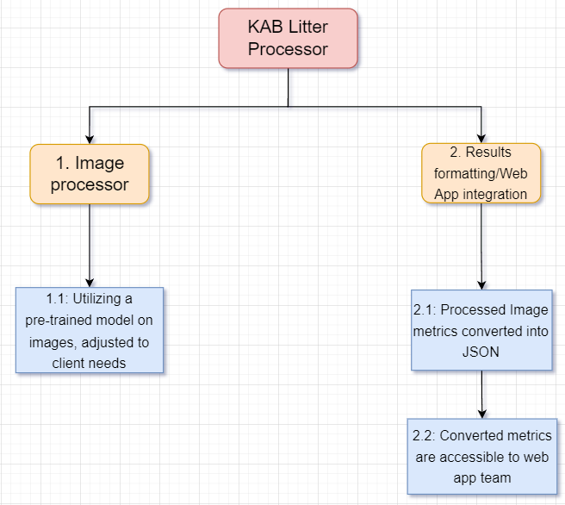

**3.2 Work Breakdown Structure**

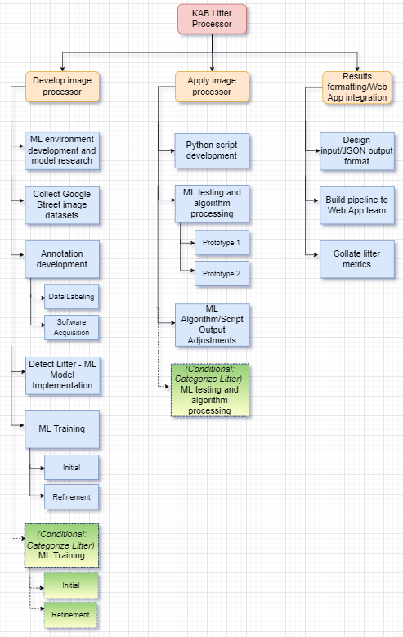

**3.3 Initial Schedule for Tasks and Deliverables**

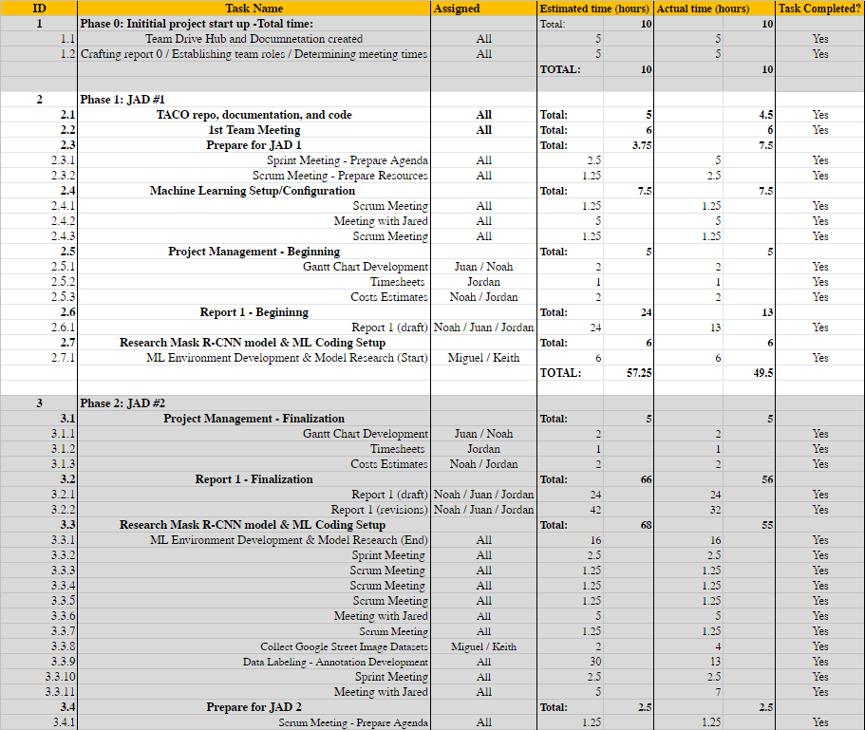

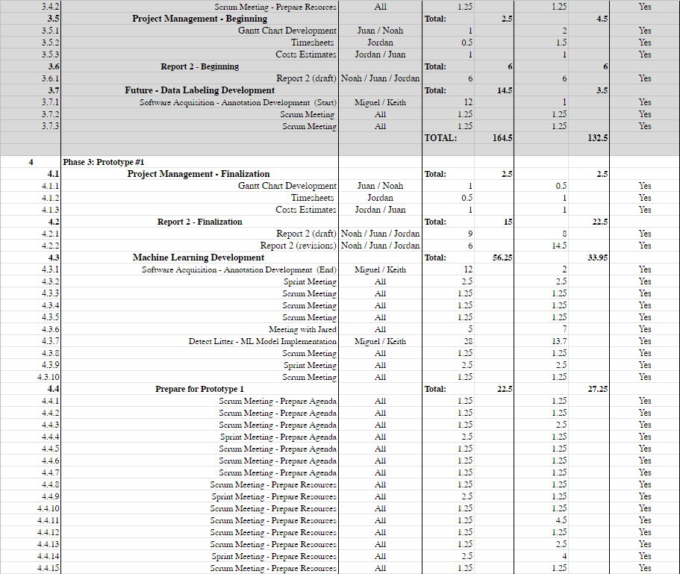

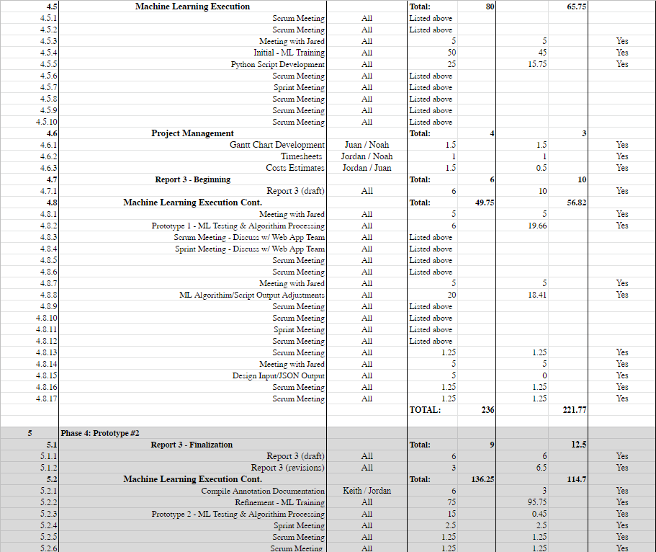

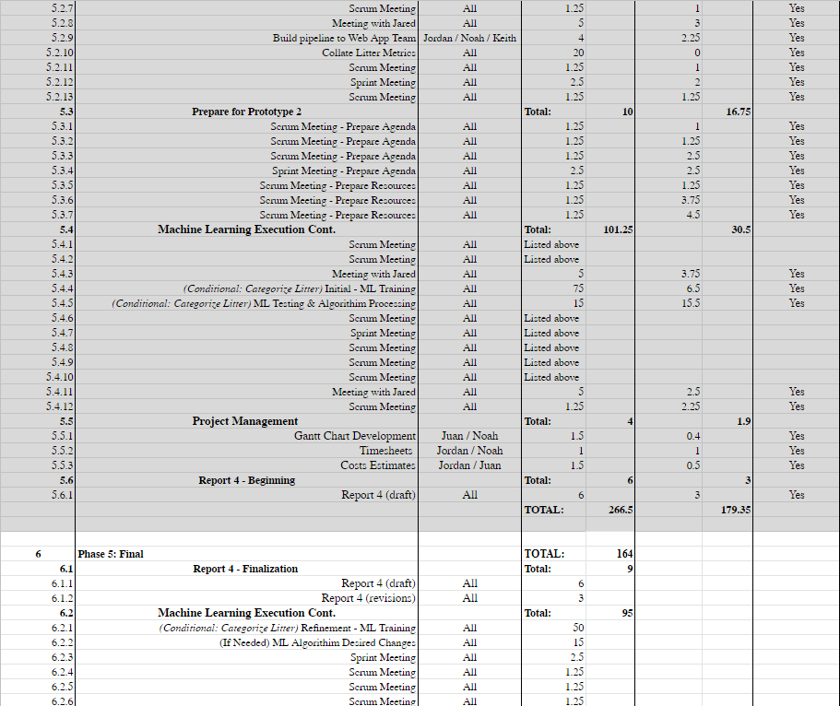

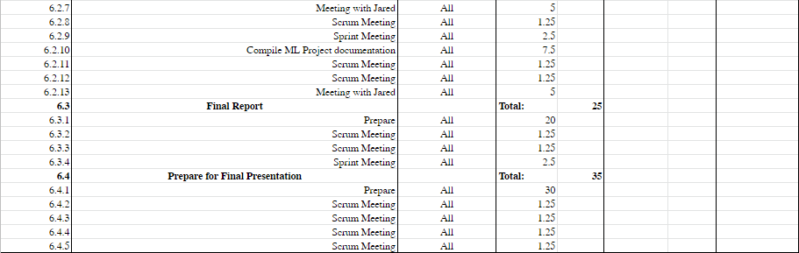

**3.4 Statement of Total Costs**

We will be charging a flat rate of $23.00 per hour for each member of the Sushi Team. The Google Cloud server will cost $0.37 cents per hour to run.

Through phase 1 of the project, it was estimated that the cost will be $1,316.75. This is based on an estimated 57.25 hours of work done by the team in this phase. In actuality, the cost was $1,138.50, having been completed in 49.5 hours of work.

During phase 2, all the members were estimated to work a combined total of 164.5 working hours. As such, the estimated cost for the phase was $3,783.50. In actuality, however, a total cost of $3,047.50 was accrued with a total of 132.5 hours.

During phase 3 of the project, the Sushi Team was projected to work for 236 hours, with a projected cost of $5,428.00 for the phase. In actuality, the team worked a total of 221.77 hours, with a total labor cost of $5,100.71. Furthermore, due to provided discounts & promotions from Google Cloud, we have accrued zero costs from the platform within this phase, during our usage of it.

During phase 4 of the project, the total number of estimated working hours spent towards development amounts to 266.5 hours, with a total cost of $6.129.50. In actuality, the cost was $4,278.46, through not only 179.35 actual labor hours, but also an accrued cost of $153.41 from our Google Cloud server.

During phase 5 of the project, the total number of estimated working hours spent towards development amounted to 164 hours. Thus, the total cost for this phase will be $3772.00.

Based on our original estimates, the final cost of this project was projected to be $20,429.75, with 888.25 hours spent by the team towards the development of the Machine Learning algorithm. However, when adjusting for the actual hours of the Phases 1, 2, 3, & 4, we expect that the total cost of the project will come to $17,337.17, accrued over a total of 747.12 labor hours, and a Google Cloud server cost of $151.41. Should alternative or additional costs become required, the above estimates will be updated accordingly.

**3.5 Gantt Chart**

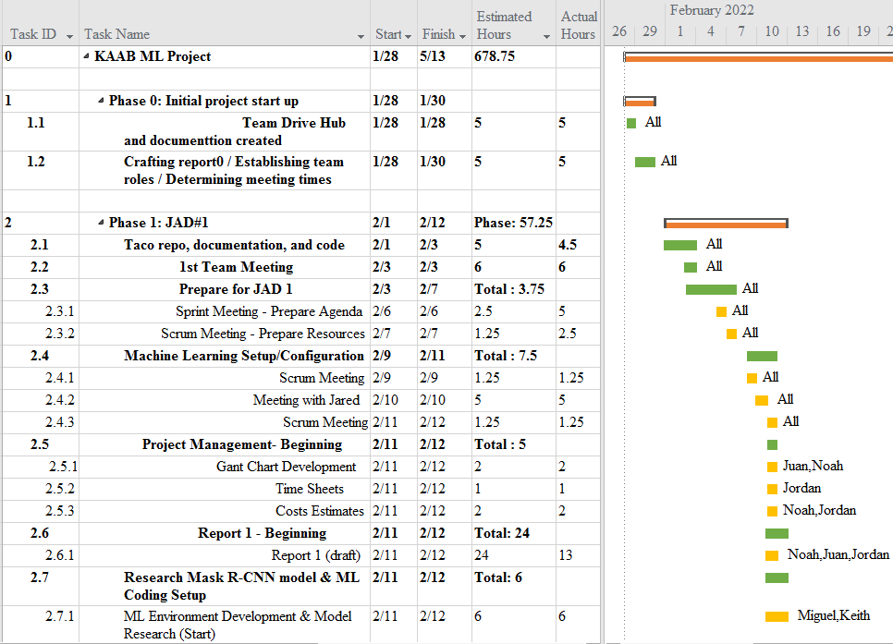

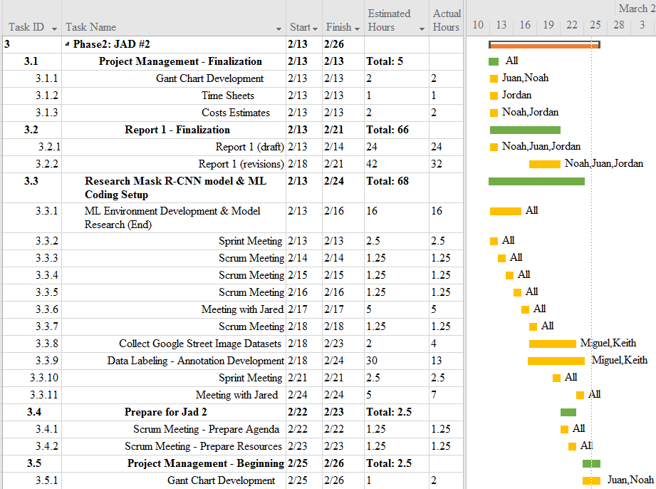

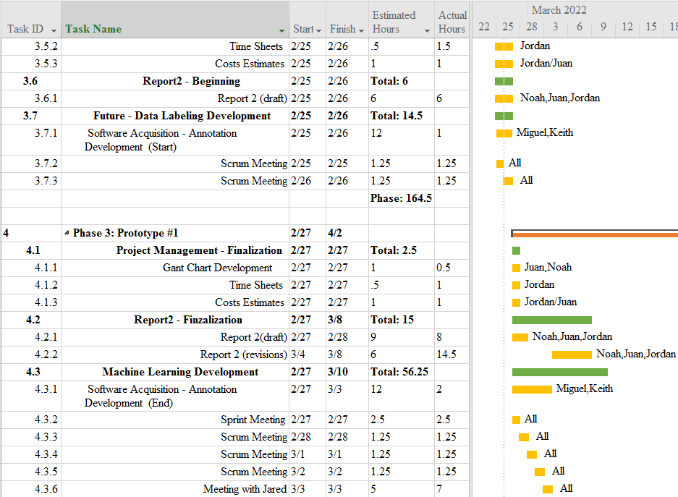

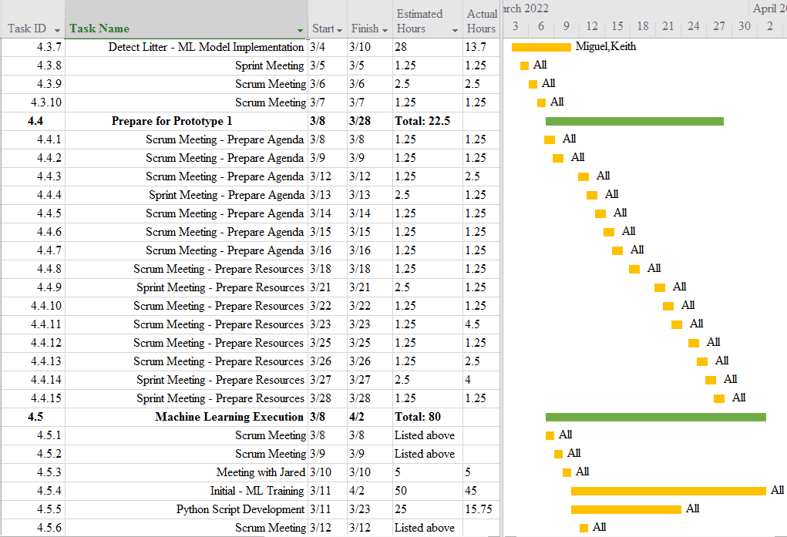

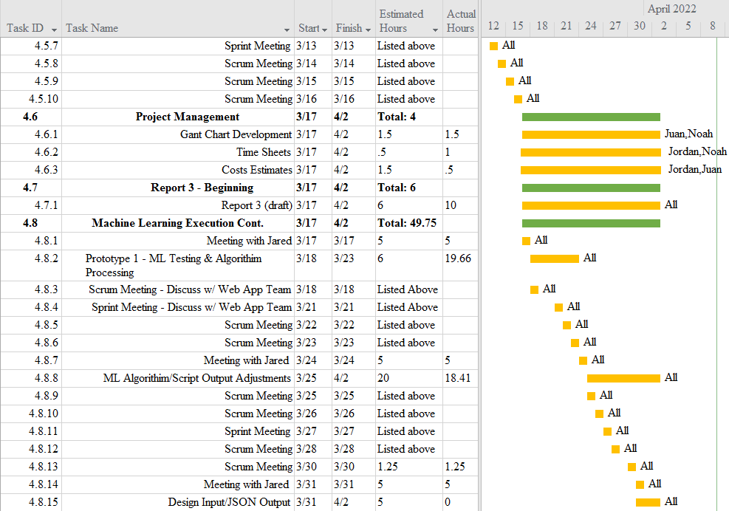

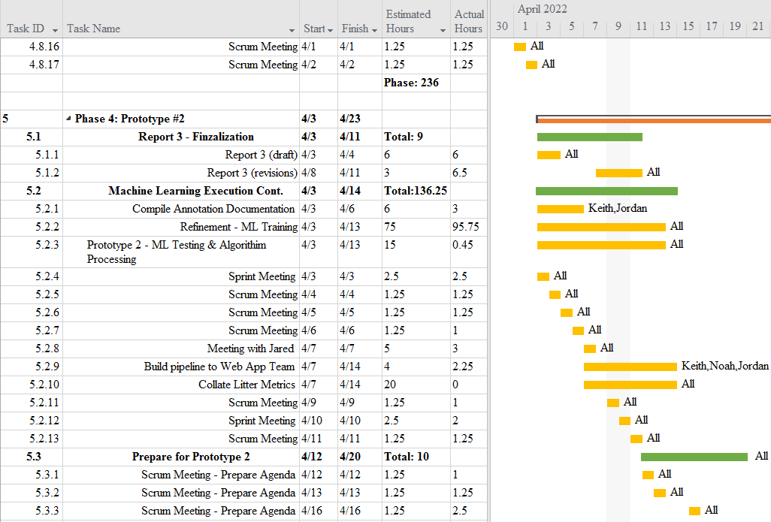

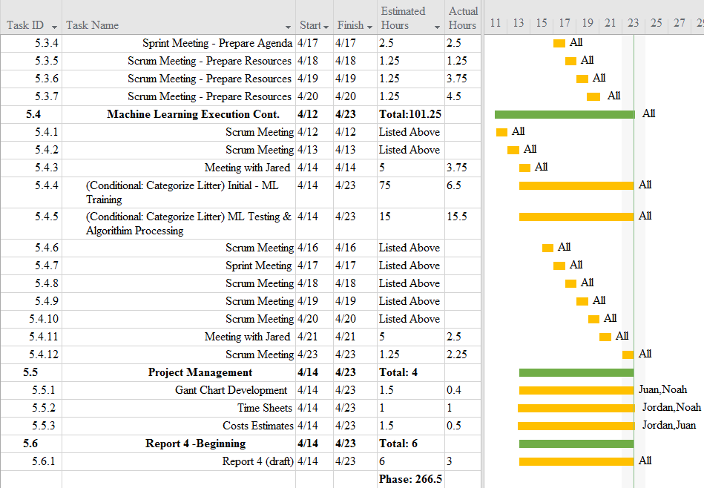

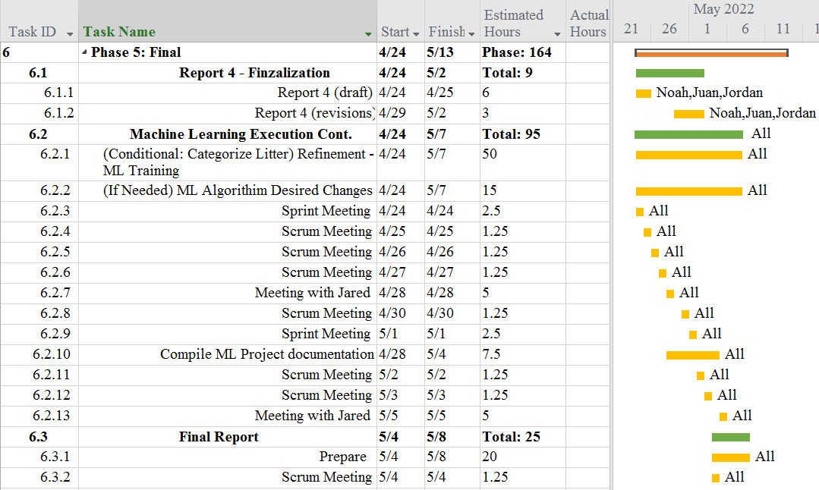

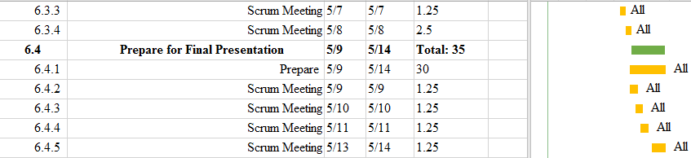

**3.6 Initial Project Cost Tracking Chart**

(As of now, by Phase 4)

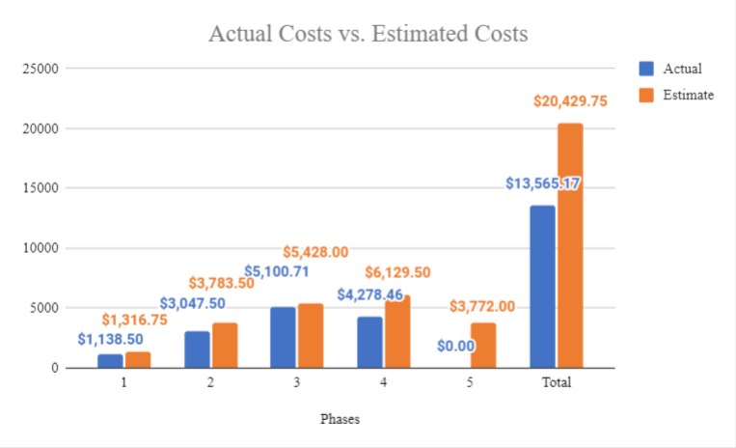

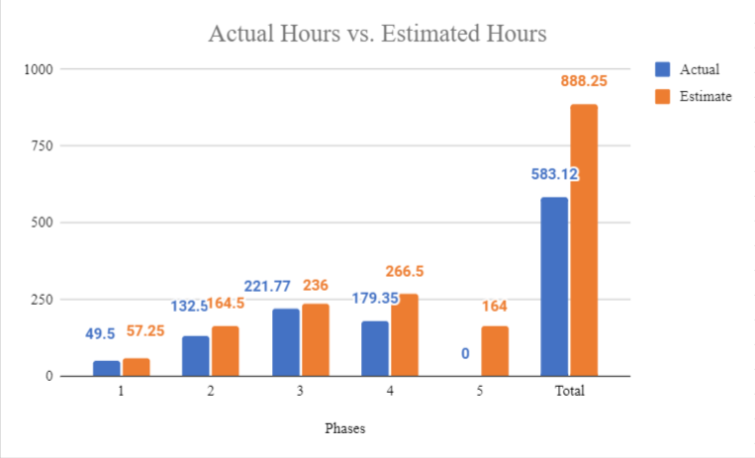

The above chart tracks the estimated and actual costs/hours for each phase of the project as well as our total accumulated costs compared to our estimated costs. We will assume an hourly rate of $23.00 per hour for this project, as we estimate to work a total of 838.25 hours. Phase 4’s actual costs are a combination of both our actual labor hour costs, and a $153.41 cost of our Google Cloud server.

**3.7 Statement of Deliverables**

The Sushi Team strives to deliver the following final products:

* A fully working machine learning algorithm that will detect instances of litter in a Google Street image. When executed, the algorithm will output the image with bounding boxes around the visible instances of litter, and display the accuracy percentages of each instance, as well as a JSON file to textualize the results. We will also strive to, though conditional, identify the type of each litter instance.
* A scheduling hook by which the web app team can use this algorithm by sending a set of images.
  + A system to format the data collected from the set of images sent using the web application.
  + A system to send the formatted data back to the web application for further use as determined by the web app team.
* A GitHub repository for the machine learning project/algorithm.
  + Source code for the algorithm.
  + Documentation, manuals, and reports for users and programmers.

Phase 5 - The final phase will result in the refinement of Prototype #2 to detect litter, and possibly categorize, as well as work out any kinks and prepare documentation to finalize the project. (Expected 5/14/22).

**3.8 Outline of Resources Needed**

The following are what the Sushi Team will be supplying:

* Knowledge of Python code, documentation, and implementation.
* Updated documentation.
* Research and testing.

The following resources are what the Sushi Team will need supplied from Jared Macshane:

* References and guidance of Machine Learning through existing models & open-source data/source code/software.
* Google Cloud Server Instance funding.
* Signage and approval for the Sushi Team to continue working on the project.
* Availability for future meetings.
* Access to Keep America Beautiful’s private server.
* Possible extra student labor to assist in Google Street image annotations for Google Street image datasets.

### 

### 4. Team - Appendix

**4.1 Access to Project**

The following will be how the Sushi Team will be collaborating during this project so-far:

* Discord.
  + https://discord.gg/dr5785e9
* GitHub
  + https://github.com/JuanGonzalez2020/KAAB-ML
* Google Cloud Server Instance.
  + Access is granted by Keith by giving him your SSH public key.
  + ssh username@34.152.63.61

**4.2 Attendance Records**

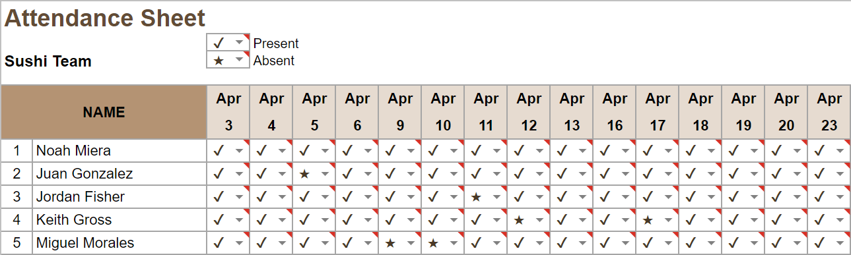

**4.3 Timesheets**

**Week 11**

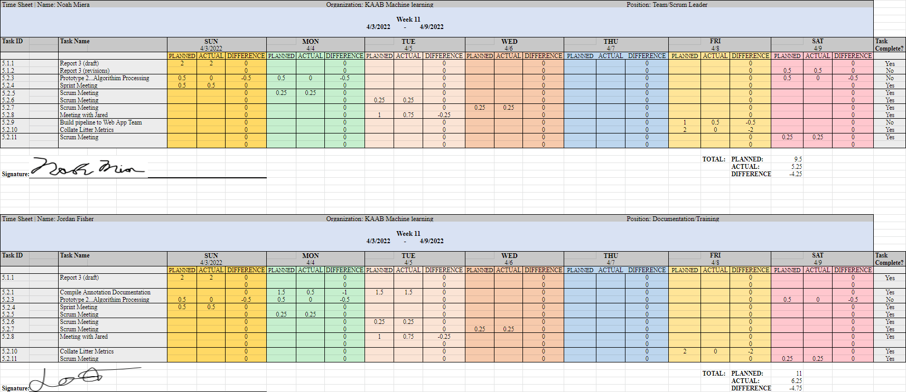

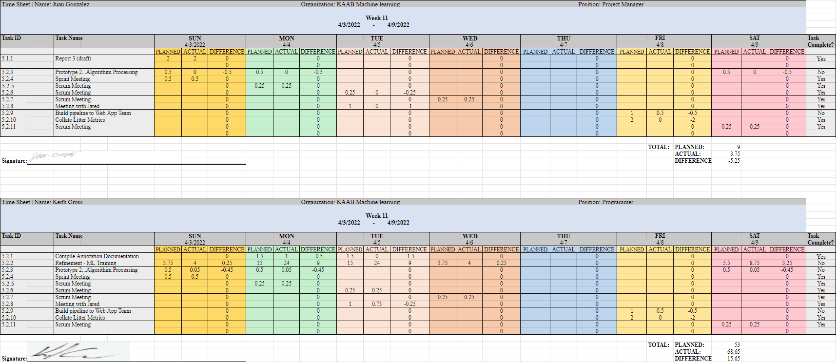

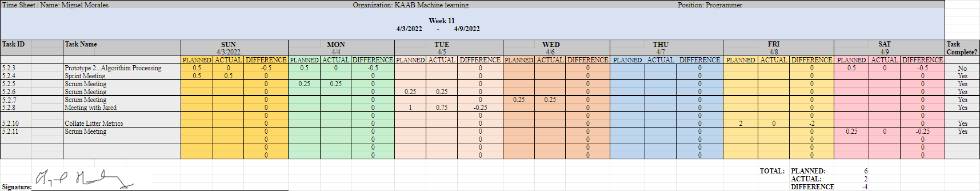

**Week 12**

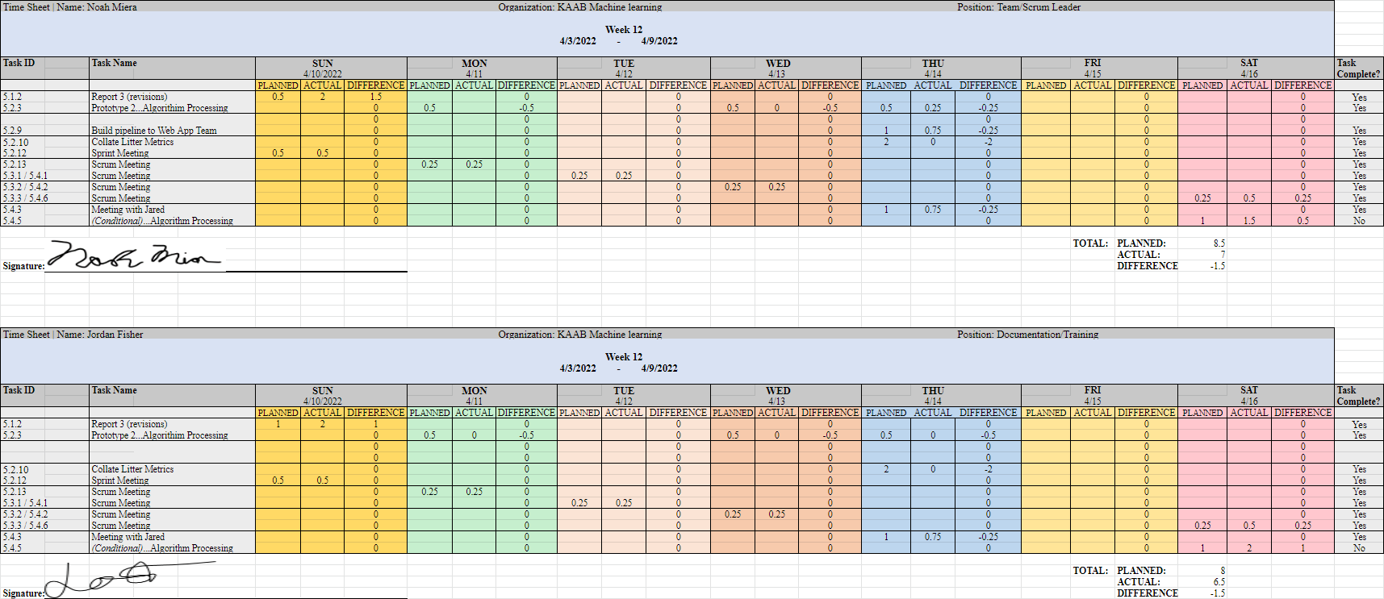

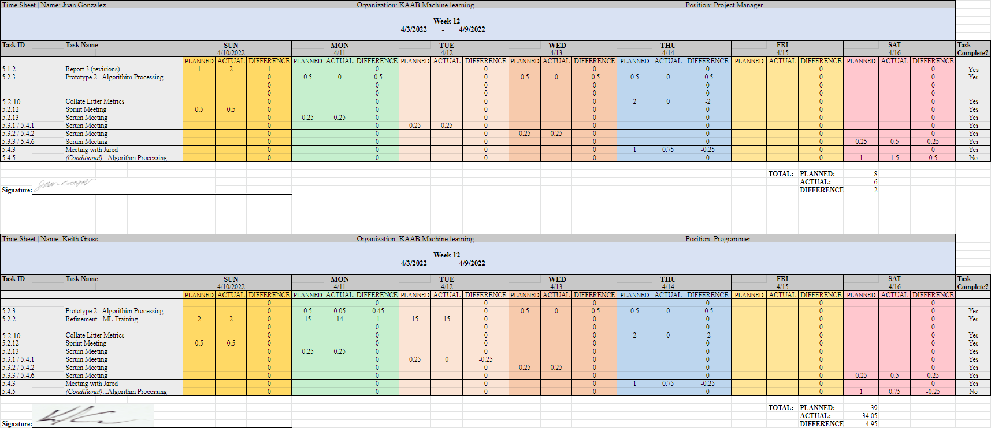

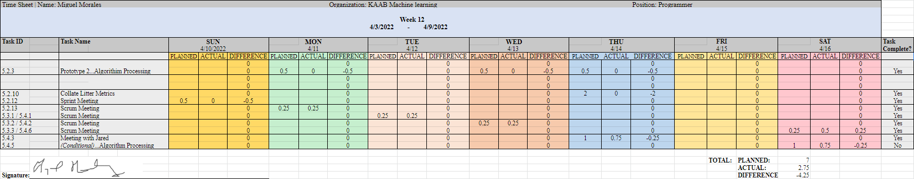

**Week 13**

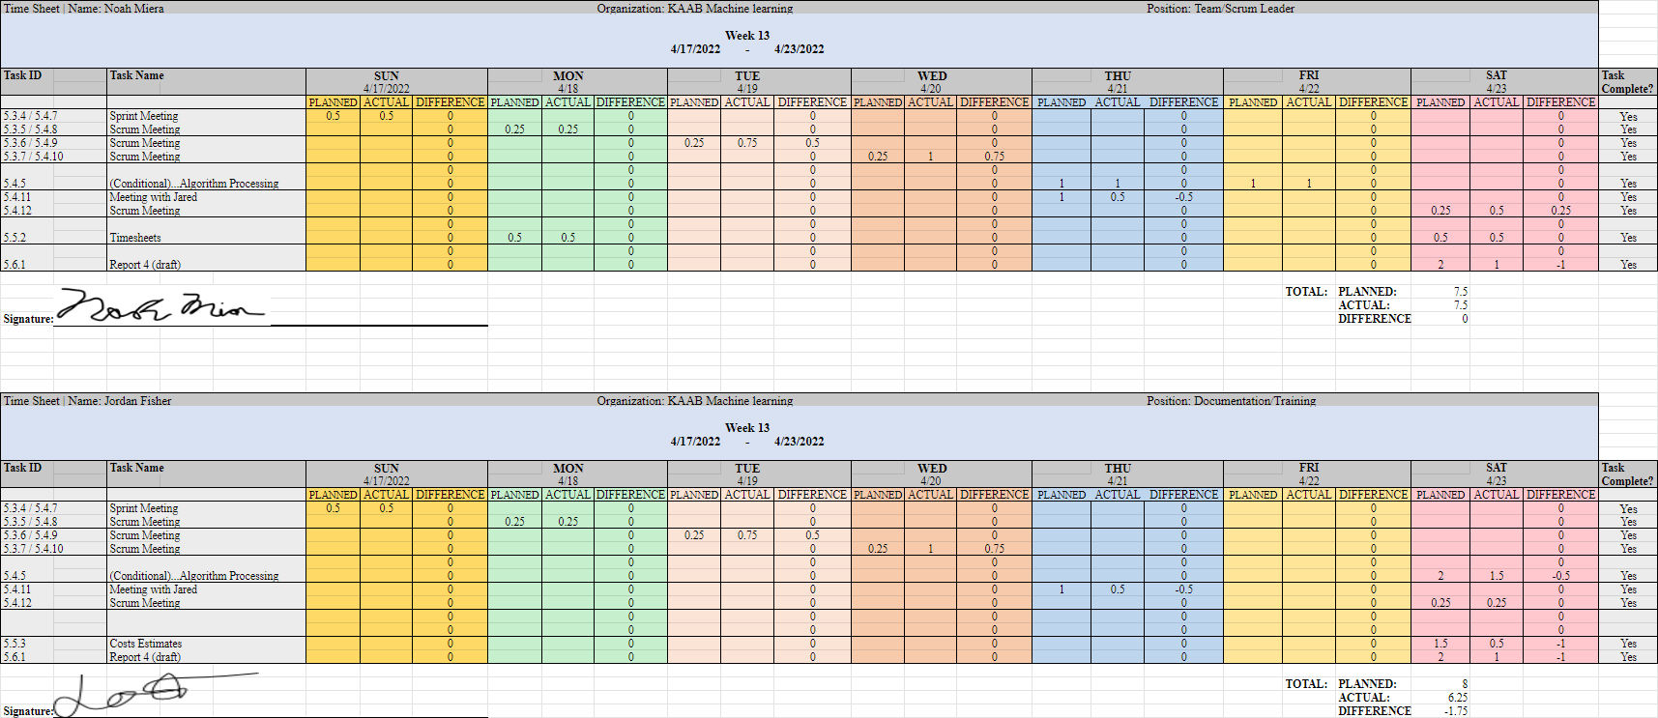

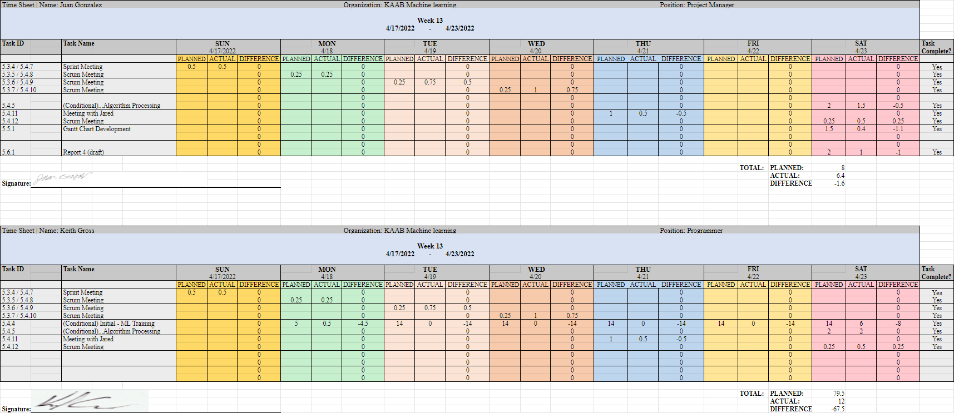

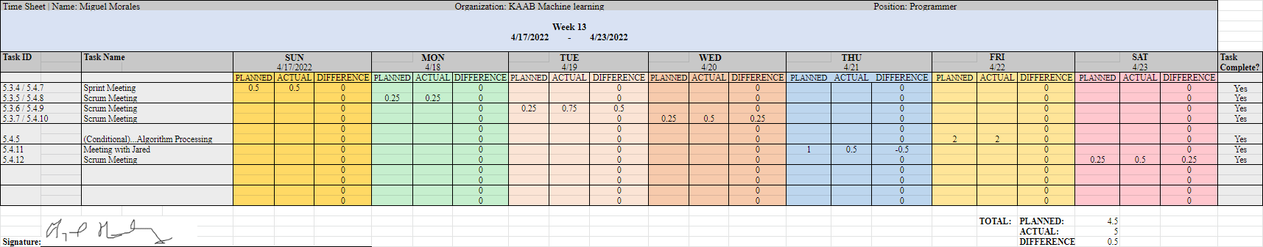

**4.4 Sprint Minutes**

Sushi Team Sprint #9 Meeting Notes

Sunday, 04.03.2022

# **Attendees**

Noah Miera: Team/Sprint Leader

Juan Gonzales: Project Manager

Jordan Fisher: Documentation/Training

Keith Gross: Programer

Miguel Morales: Programer

# **Minutes:**

## 12:00 PM: Discussion of Retraining The Current Model

* Weights are being changed. Working on new ones from scratch.
* Model will train for 10 epochs and then change a parameter. This will help tune parameters and produce a new set of weights
* Process should be done soon
* Training time currently estimated as a total of 50 hours

## 12:17 PM: Confirmation of List of Tasks

## 12:19 AM: Discussion Report 3D Remaining Edits

* Cost estimates
* Gantt chart
* Statement of costs

## 12:22 PM Upcoming Tasks Overview

## 12:30 PM Meeting adjourned!

## 

Sushi Team Sprint #10 Meeting Notes

Sunday, 04.10.2022

# **Attendees**

Noah Miera: Team/Sprint Leader

Juan Gonzales: Project Manager

Jordan Fisher: Documentation/Training

Keith Gross: Programer

Miguel Morales: Programer

# **Minutes:**

## 12:00 PM: Review of previous discussions

* Some changes may need to be implemented to account for web app team
* Currently training parameters will be approached differently per project director’s feedback
  + Ignoring everything under 7 pixels
  + Map level is currently improving
* Jared is reviewing the images to determine what litter categories would be appropriate
* Annotation documentation has been sent out
* Currently waiting on new dataset

## 12:10 PM: Discussion of Report 3 Edits

* Review of feedback
* Review of completed edits
* Review of edits left to be implemented

## 12:19 AM: Discussion Report 3D Remaining Edits

* Cost estimates
* Gantt chart
* Statement of costs

## 12:30 PM Meeting adjourned!

Sushi Team Sprint #11 Meeting Notes

Sunday, 04.17.2022

# **Attendees**

Noah Miera: Team/Sprint Leader

Juan Gonzales: Project Manager

Jordan Fisher: Documentation/Training

Keith Gross: Programer

Miguel Morales: Programer

# **Minutes:**

## 12:00 PM: Discussion of Annotation reviews

* Many of the annotations by the students were done incorrectly
* A good handful were done well

## 12:10 PM: Discussion of Next steps with Roboflow

* Create copies of datasets for backup purposes
* Ensure that remaining images are annotated

## 12:13 PM: Discussion of Upcoming Prototype Meeting

* Much of the changes are simply developing on what we have done thus far
* Keep old diagrams to show what has changed when compared with new ones
* Cover the same topics per person as last time

## 12:36 PM Meeting adjourned!

## 